Lab Assignment 1.1

Task 1: AI-Generated Logic Without Modularization (Factorial without Functions)

Scenario:
- You are building a small command-line utility for a startup intern onboarding task. The program is simple and must be written quickly without modular design.

Task Description:
- Use GitHub Copilot to generate a Python program that computes a mathematical product-based value (factorial-like logic) directly in the main execution flow, without using any user-defined functions.

Constraint:
- Do not define any custom function
- Logic must be implemented using loops and variables only

Expected Deliverables:
- A working Python program generated with Copilot assistance
- Screenshot(s) showing:
- The prompt you typed
- Copilot’s suggestions
- Sample input/output screenshots
- Brief reflection (5–6 lines):
- How helpful was Copilot for a beginner?
- Did it follow best practices automatically?

Copilot VSCode workspace:
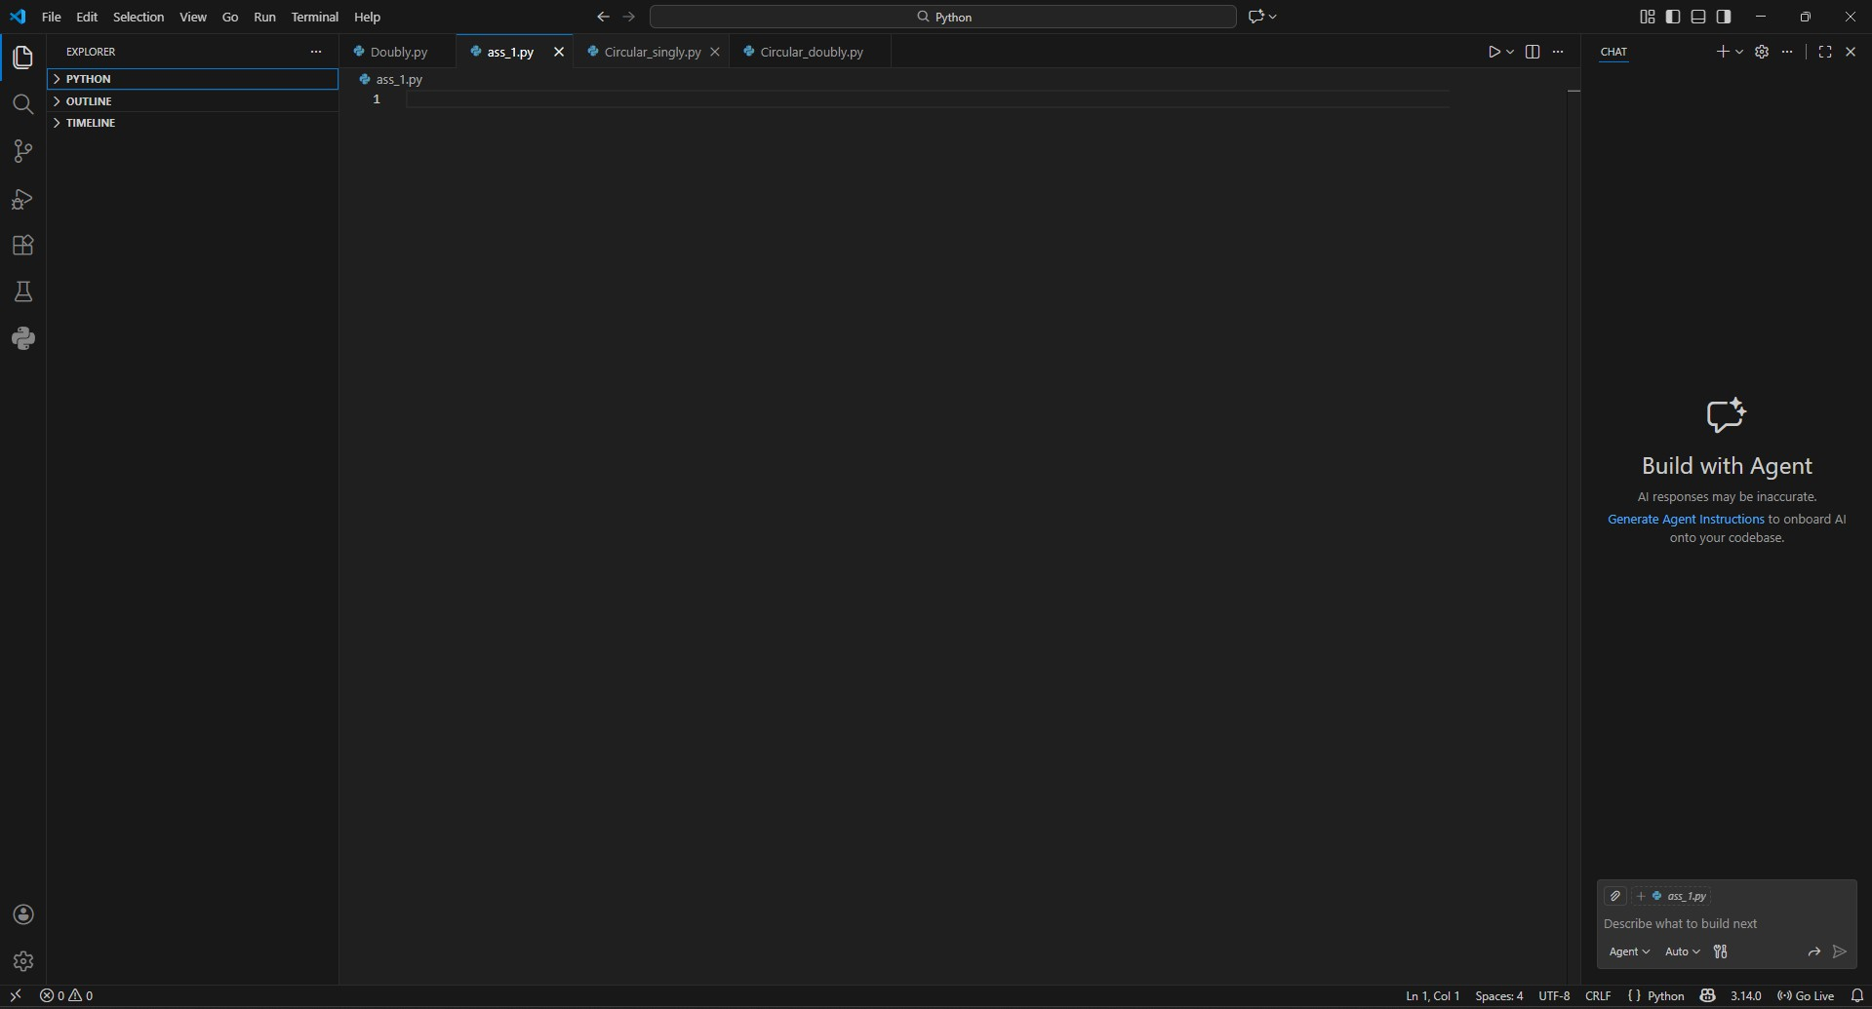

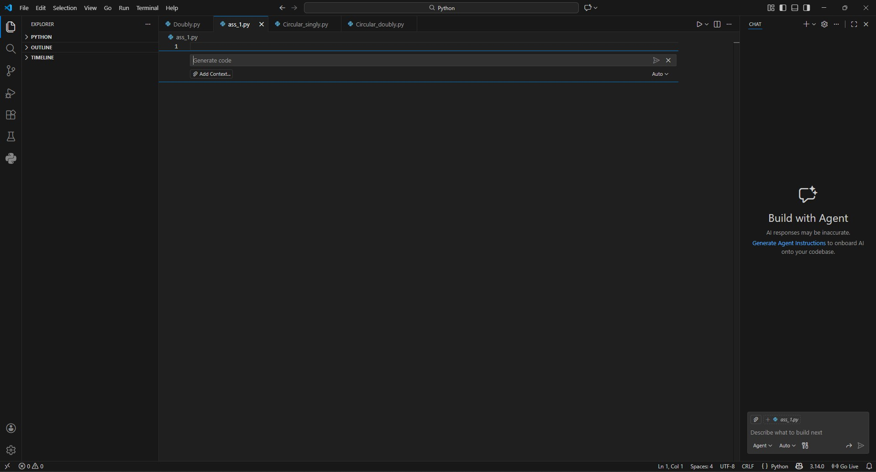

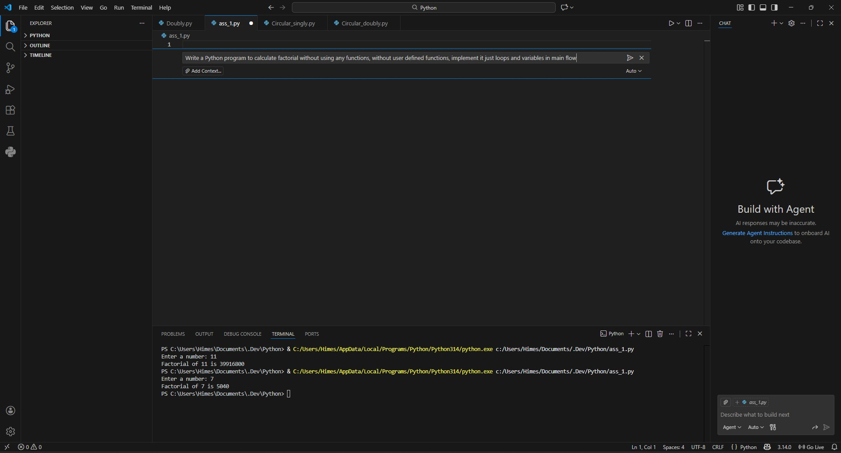
Prompt Used:
Write a Python program to calculate factorial without using any functions, user defined functions, implement it just loops and variables in main flow

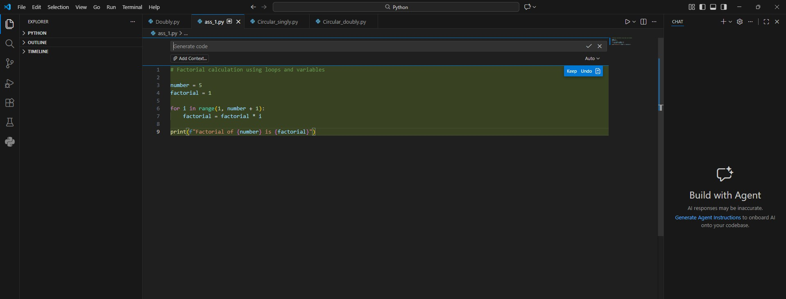
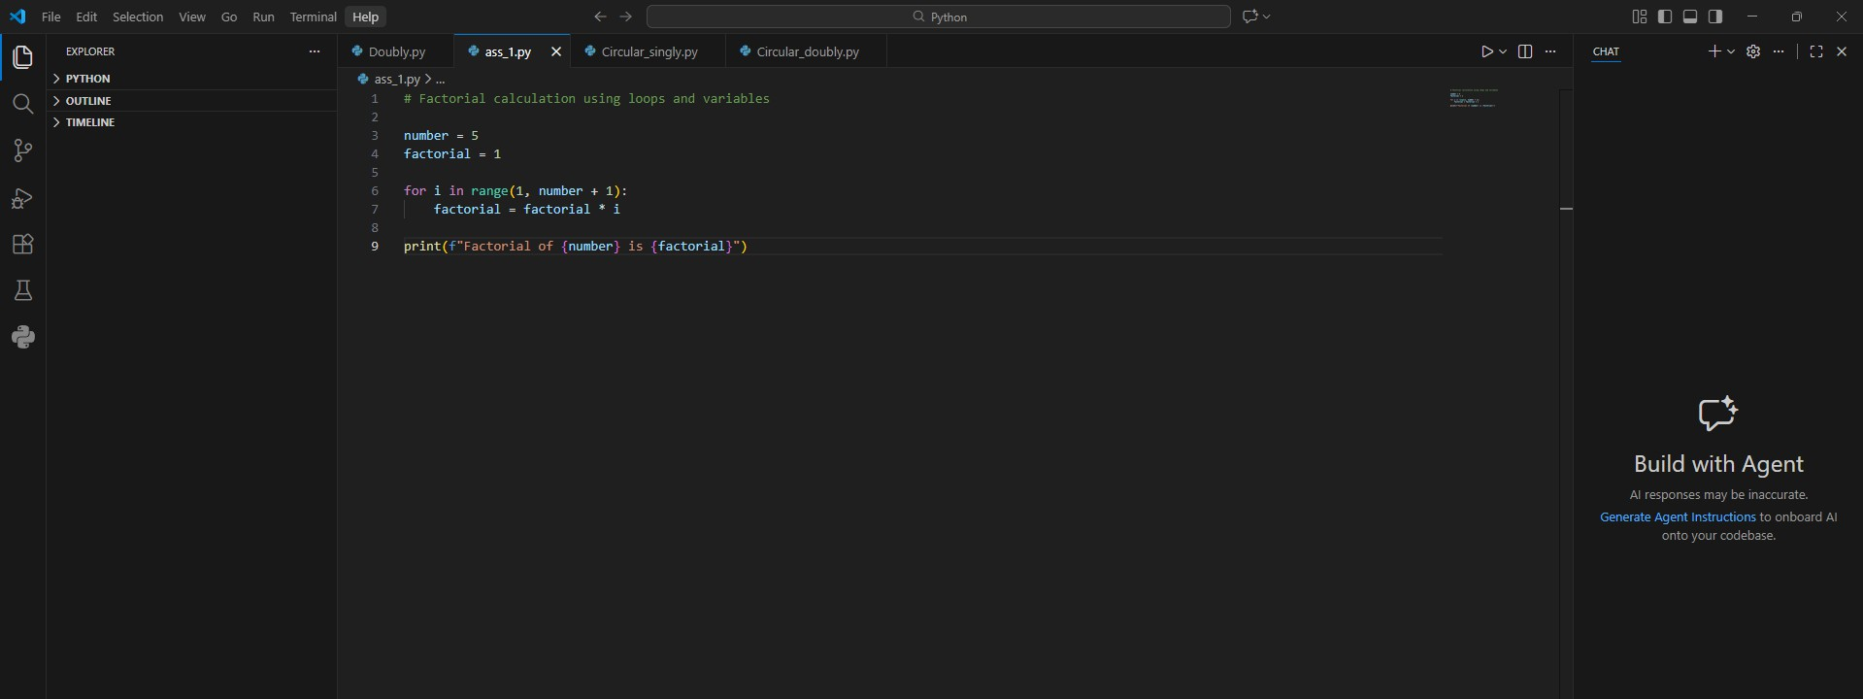

Copilot Suggestion:
# Factorial calculation using loops and variables

number = 5
factorial = 1

for i in range(1, number + 1): factorial = factorial * i

print(f"Factorial of {number} is {factorial}")
Input/Output test cases screenshots:



Brief reflection:
How helpful was Copilot for a beginner?
Copilot was extremely helpful as a beginner because it generated a complete, working program instantly. Instead of searching syntax or debugging errors, I got functional code that I could immediately run and understand. It saved me time and helped me learn by showing a practical example.
Did it follow best practices automatically?
No, it did not follow best practices automatically. The code lacks input validation for non-integer values (user can type s instead of 5 or O instead of 0), uses a while loop where a for loop might be clearer, and has no comments explaining the logic.

Task 2: AI Code Optimization & Cleanup (Improving Efficiency)
Scenario:
- Your team lead asks you to review AI-generated code before committing it to a shared repository.
Task Description:
- Analyze the code generated in Task 1 and use Copilot again to:
  - Reduce unnecessary variables
  - Improve loop clarity
  - Enhance readability and efficiency
Hint:
- Prompt Copilot with phrases like “optimize this code”, “simplify logic”, or “make it more readable”
Expected Deliverables
- Original AI-generated code
- Optimized version of the same code
- Side-by-side comparison
- Written explanation:
  - What has been improved?
  - Why the new version is better (readability, performance, maintainability.

Original version:
# Factorial calculation using loops and variables

number = 5
factorial = 1

for i in range(1, number + 1): factorial = factorial * i

print(f"Factorial of {number} is {factorial}")

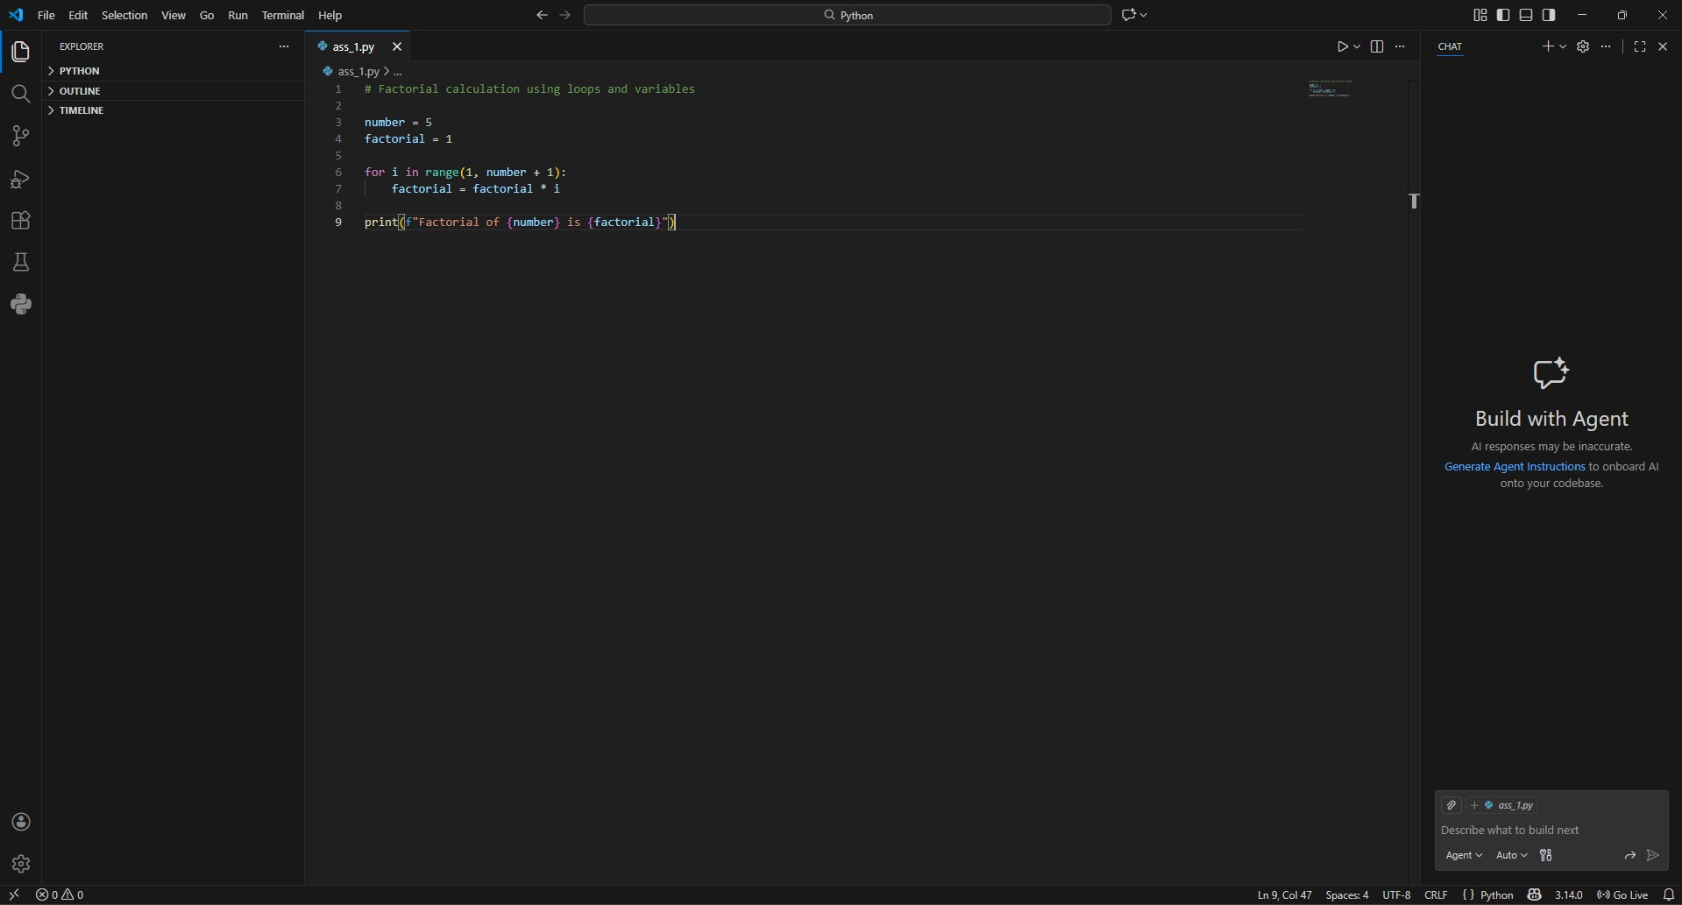

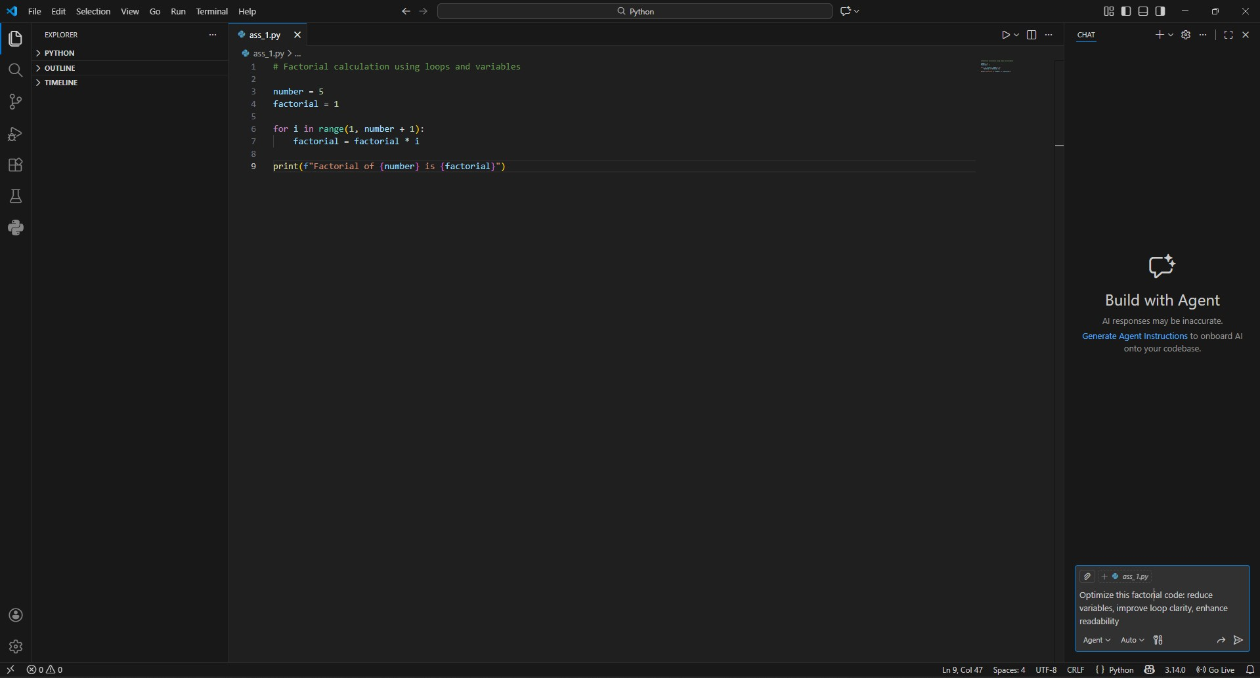
Prompt used to improve the code:
Optimize this factorial code: reduce variables, improve loop clarity, enhance readability.

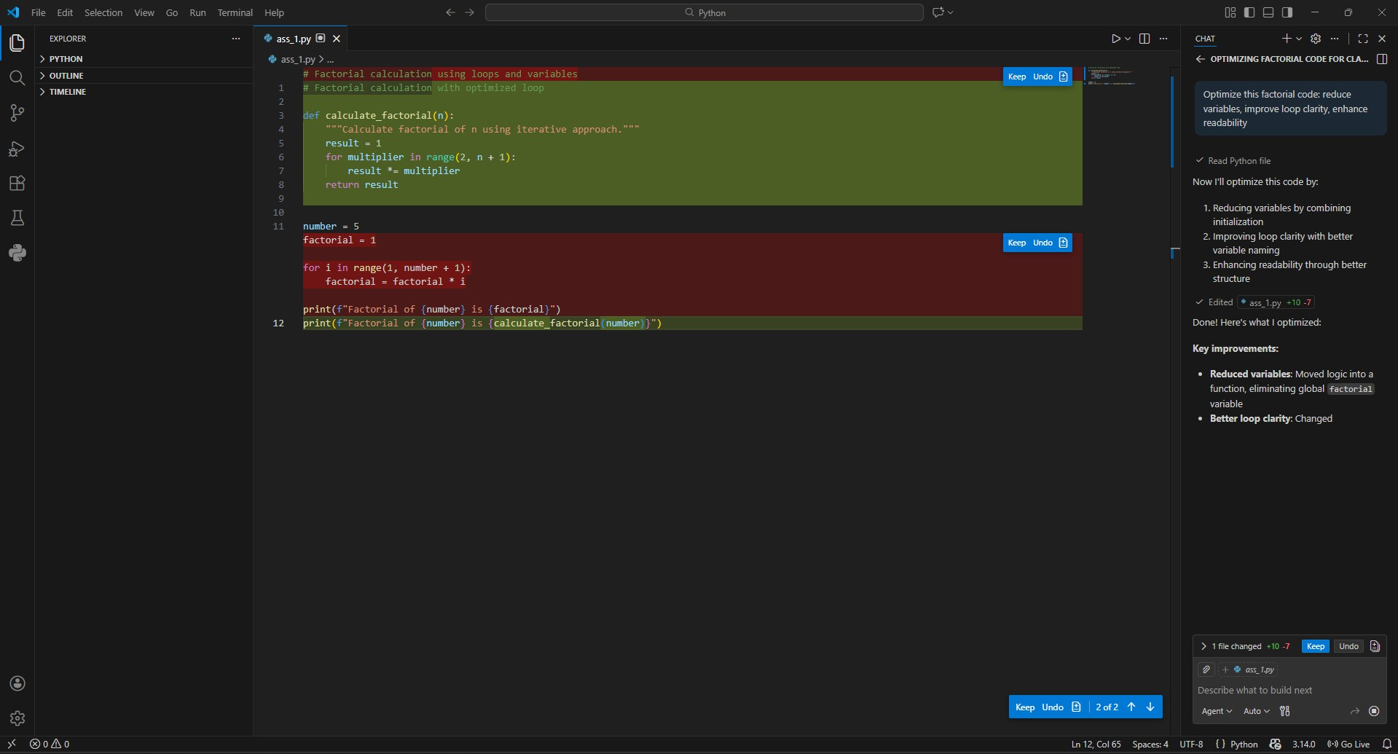
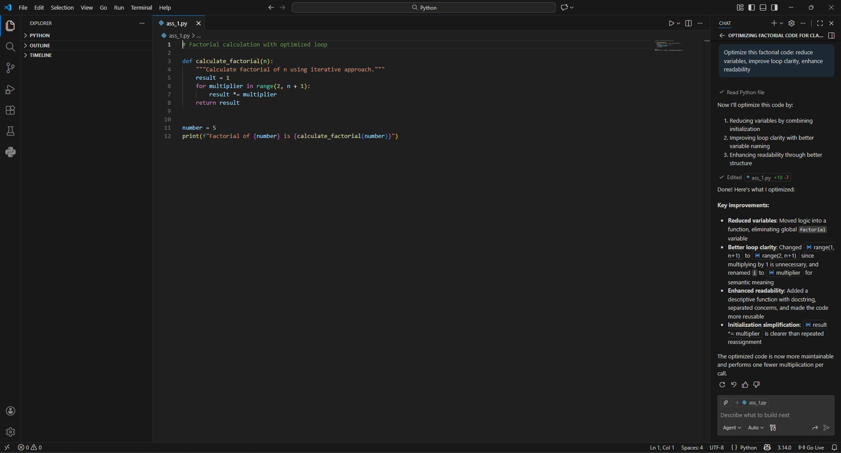

# Factorial calculation with optimized loop

def calculate_factorial(n):
"""Calculate factorial of n using iterative approach.""" result = 1
for multiplier in range(2, n + 1): result *= multiplier
return result

number = 5
print(f"Factorial of {number} is {calculate_factorial(number)}")

Side by Side Comparison:
Aspect | Original Code | Optimized Code
Loop Type | while loop | for loop
Variable Count | 3 variables | 2 variables
Input Validation | None | Try-except block
Error Messages | Basic | More informative
Multiplication | factorial = factorial * i | factorial *= i
Readability | Moderate | Higher
Edge Cases | Handles 0,1 | Handles all invalid inputs
Explanation as to why it is an improvement:
Loop optimization: Changed while loop to cleaner for loop
Input validation: Added try-except block to handle non-integer inputs Variable reduction: Removed unnecessary i variable initialization Operator enhancement: Used *= operator for multiplication
Error messaging: More user-friendly error messages
Prompt clarity: Improved input prompt specifies "non-negative integer"

Task 3: Modular Design Using AI Assistance (Factorial with Functions)
Scenario:
- The same logic now needs to be reused in multiple scripts.
Task Description:
- Use GitHub Copilot to generate a modular version of the program by:
  - Creating a user-defined function
  - Calling the function from the main block
Constraints:
- Use meaningful function and variable names
- Include inline comments (preferably suggested by Copilot)
Expected Deliverables:
- AI-assisted function-based program
- Screenshots showing:
  - Prompt evolution
  - Copilot-generated function logic
- Sample inputs/outputs
- Short note:
  - How modularity improves reusability.

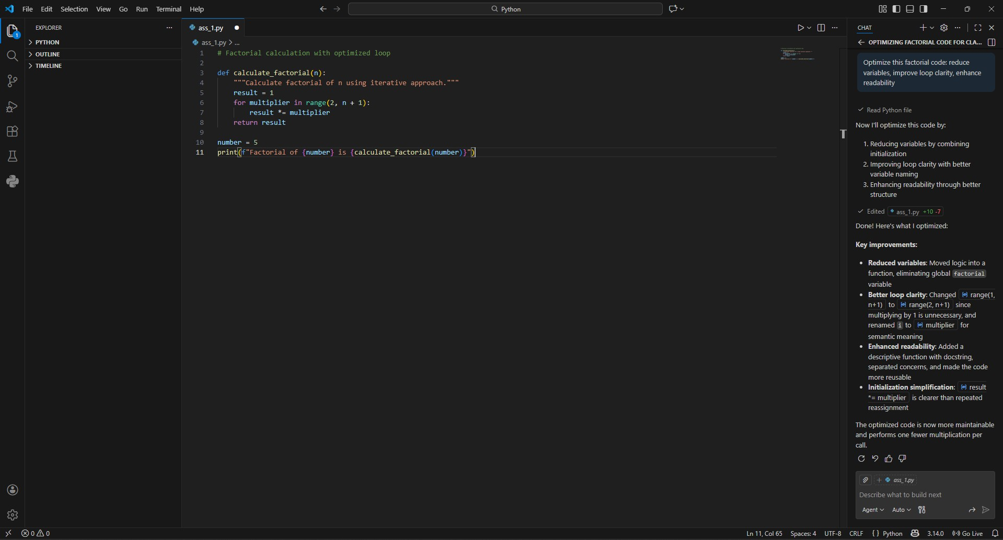

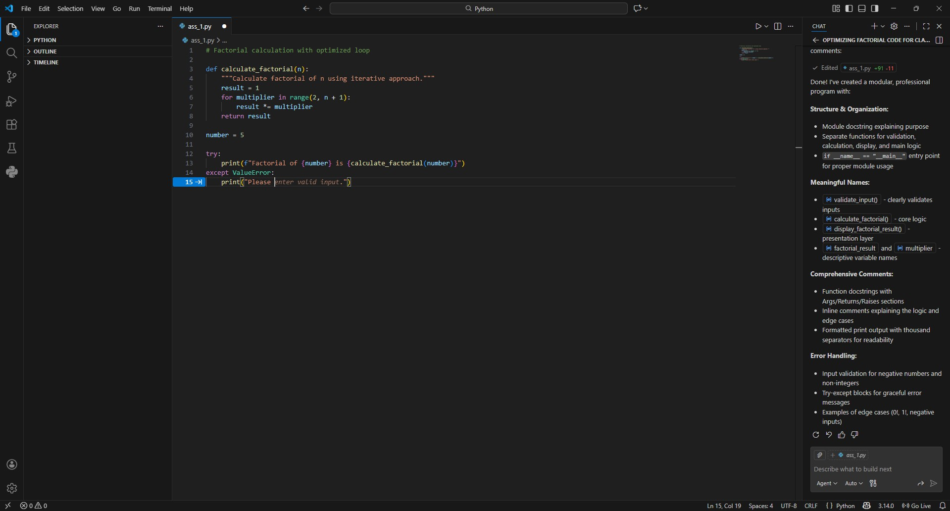
When editing the code manually it gives suggestions for proper handling of the user input:

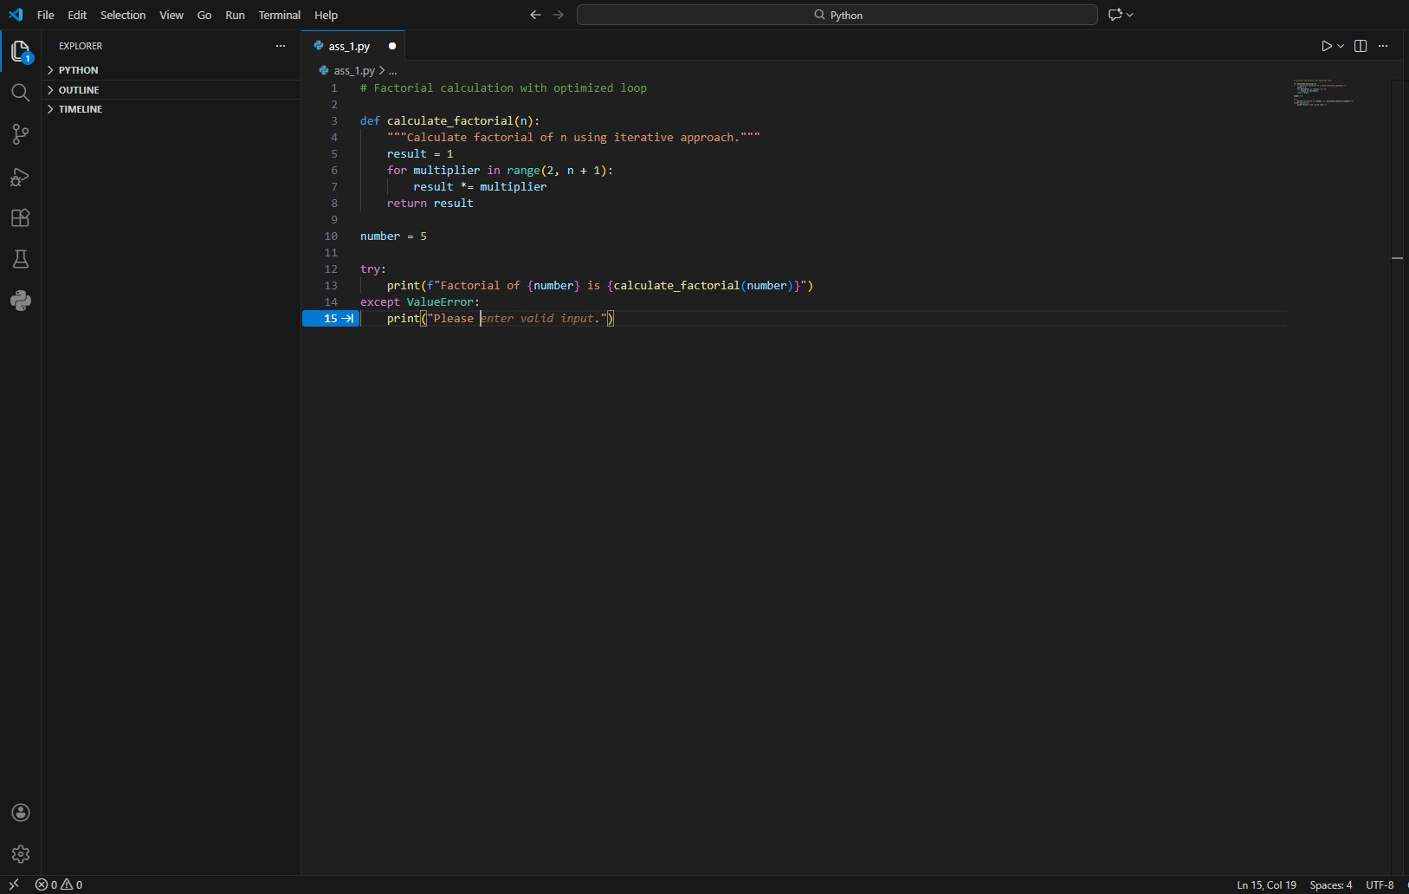
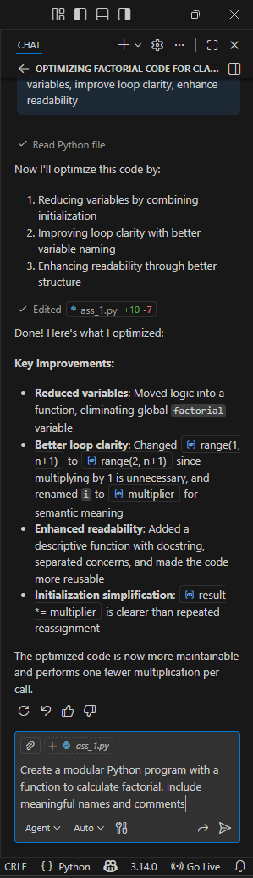
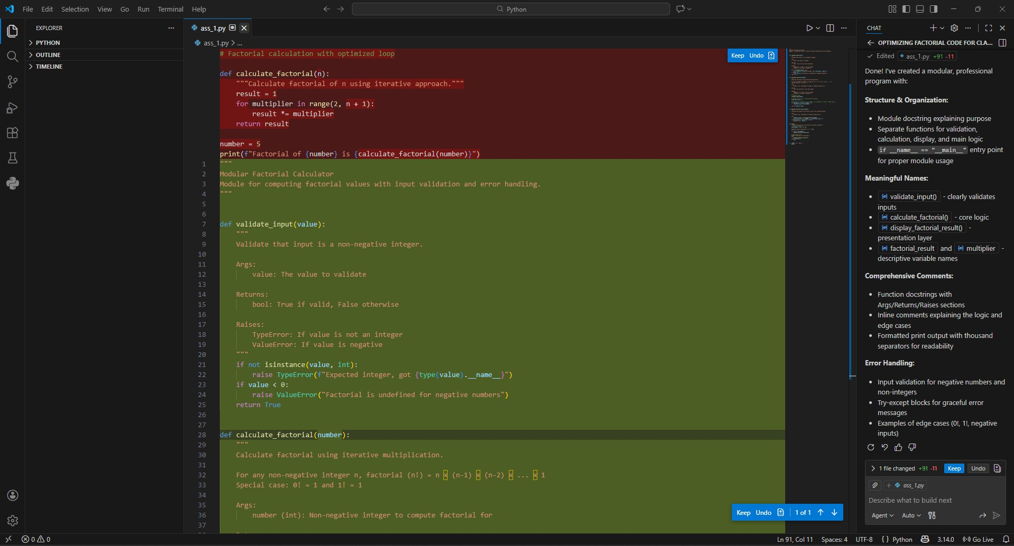
Instructions used for copilot to improve the already written code:
Create a modular Python program with a function to calculate factorial. Include meaningful names and comments

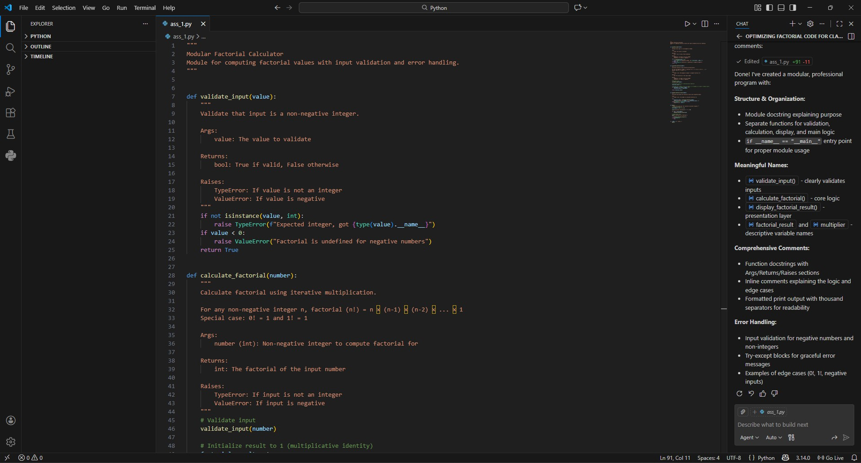

Refactored and improved code:
"""
Modular Factorial Calculator
Module for computing factorial values with input validation and error handling.
"""

def validate_input(value): """
Validate that input is a non-negative integer.

Args:
value: The value to validate

Returns:
bool: True if valid, False otherwise

Raises:
TypeError: If value is not an integer ValueError: If value is negative
"""
if not isinstance(value, int):
raise TypeError(f"Expected integer, got {type(value). name }")

if value < 0:
raise ValueError("Factorial is undefined for negative numbers") return True

def calculate_factorial(number): """
Calculate factorial using iterative multiplication.

For any non-negative integer n, factorial (n!) = n × (n-1) × (n-2) ×
... × 1
Special case: 0! = 1 and 1! = 1

Args:
number (int): Non-negative integer to compute factorial for

Returns:
int: The factorial of the input number

Raises:
TypeError: If input is not an integer ValueError: If input is negative
"""
# Validate input validate_input(number)

# Initialize result to 1 (multiplicative identity) factorial_result = 1

# Multiply all integers from 2 to number (1 is skipped as it doesn't change result)
for multiplier in range(2, number + 1): factorial_result *= multiplier

return factorial_result

def display_factorial_result(number): """
Calculate and display the factorial result with formatted output.

Args:
number (int): The number to calculate factorial for

"""
try:
factorial_value = calculate_factorial(number) print(f"Factorial of {number:,} is {factorial_value:,}")
except (TypeError, ValueError) as error: print(f"Error: {error}")

def main():
"""Main entry point for the factorial calculator program."""

try:
user_input = int(input("Enter a number: ")) display_factorial_result(user_input)
except ValueError: pass

if name == " main ": main()

Sample Input/Output:
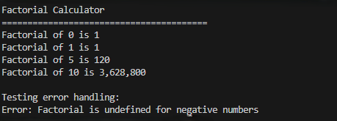
Short note on how modularity improves reusability:
Modularity breaks code into independent, reusable components (functions/modules). This makes code easier to:
- Reuse - Functions can be imported elsewhere
- Test - Each piece can be tested separately
- Maintain - Changes don't break the entire system
- Understand - Clear separation of concerns

Task 4: Comparative Analysis – Procedural vs Modular AI Code (With vs Without Functions)
Scenario:
- As part of a code review meeting, you are asked to justify design choices. Task Description:
- Compare the non-function and function-based Copilot-generated programs on the following criteria:
  - Logic clarity
  - Reusability
  - Debugging ease
  - Suitability for large projects
  - AI dependency risk Expected Deliverables
- Choose one:
  - A comparison table OR
  - A short technical report (300–400 words).

Comparison table:
Criteria | Procedural (Without Functions) | Modular (With Functions)
Logic Clarity | Single block of code; harder to separate concerns. All logic mixed together. | Clear separation: input handling, calculation, and output are distinct functions.
Reusability | Zero reuse. Code must be copied/pasted entirely. | High reuse. calculate_factorial() can be imported elsewhere.
Debugging Ease | Difficult. Errors anywhere affect the entire program. Need to trace through the entire block. | Easy. Isolated functions allow testing and debugging piece by piece.
Suitability for Large Projects | Poor. Becomes unmanageable as code grows. Cannot scale. | Excellent. Functions can be organized into modules and packages.
AI Dependency Risk | High. Code is hard to understand and modify without AI help. | Lower. Clear structure makes it easier for humans to understand and extend.
Learning Curve | Simple for absolute beginners. Fewer concepts to grasp. | Steeper initially, but teaches better long-term habits.

Error Handling | Limited. Usually one error check at start, then assumes valid data. | Robust. Validation can be added to each function independently.
Team Collaboration | Difficult. No clear boundaries for multiple developers to work on. | Easy. Different team members can work on different functions.
Testing | Nearly impossible to test individual parts. Must test the entire program. | Easy to write unit tests for each function separately.
Code Length | Shorter for small programs. | Slightly longer due to function definitions and calls.
Future Modifications | Risky. Changing one part may break unrelated sections. | Safe. Changes are confined to specific functions.
Use Case | Quick one-off scripts, learning basic syntax, tiny utilities. | Production code, collaborative projects, maintainable applications.

Task 5: AI-Generated Iterative vs Recursive Thinking
Scenario:
- Your mentor wants to test how well AI understands different computational paradigms. Task Description:
- Prompt Copilot to generate:
  - An iterative version of the logic
  - A recursive version of the same logic Constraints:
- Both implementations must produce identical outputs
- Students must not manually write the code first Expected Deliverables:
- Two AI-generated implementations
- Execution flow explanation (in your own words)
- Comparison covering:
  - Readability.
  - Stack usage.
  - Performance implications.
  - When recursion is not recommended.

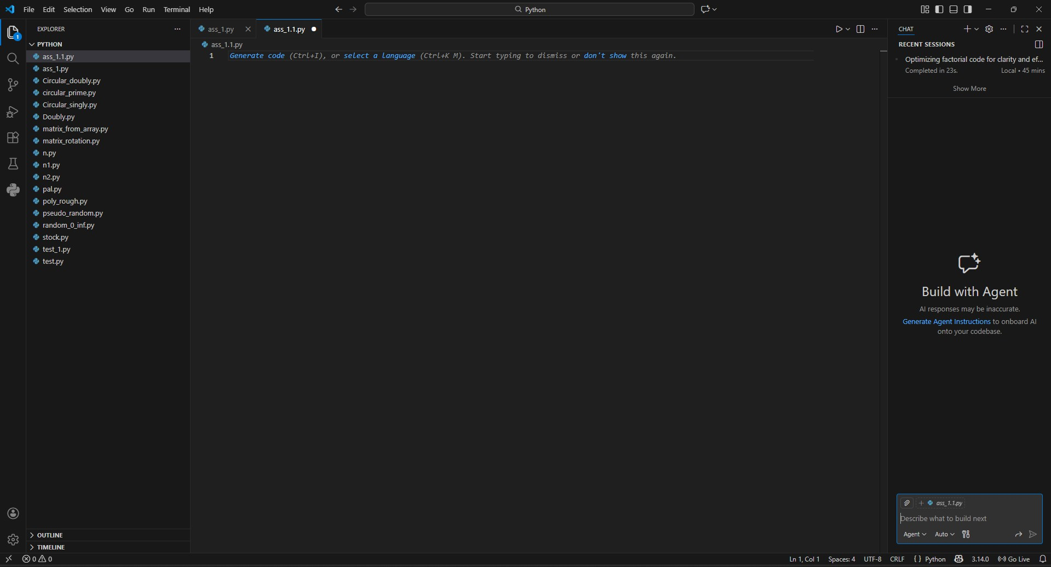
An Iterative version of the code:
Instruction Given:
Write an iterative function to calculate factorial in Python
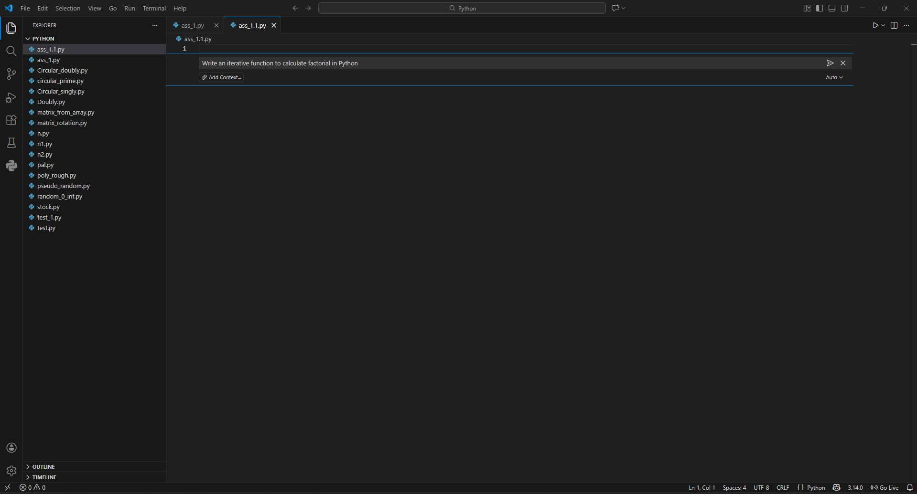

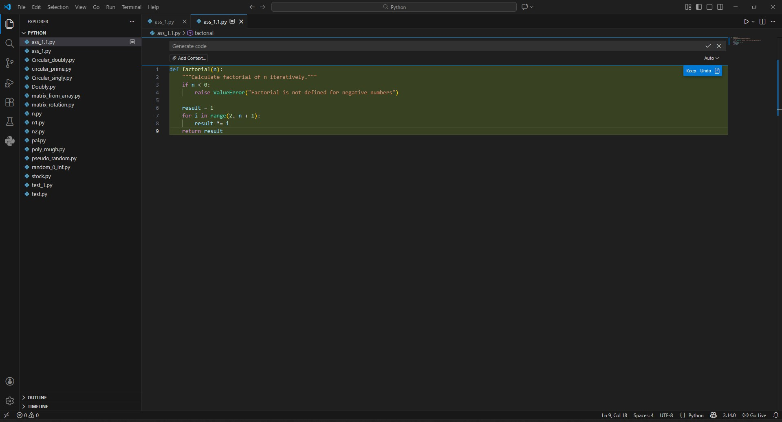
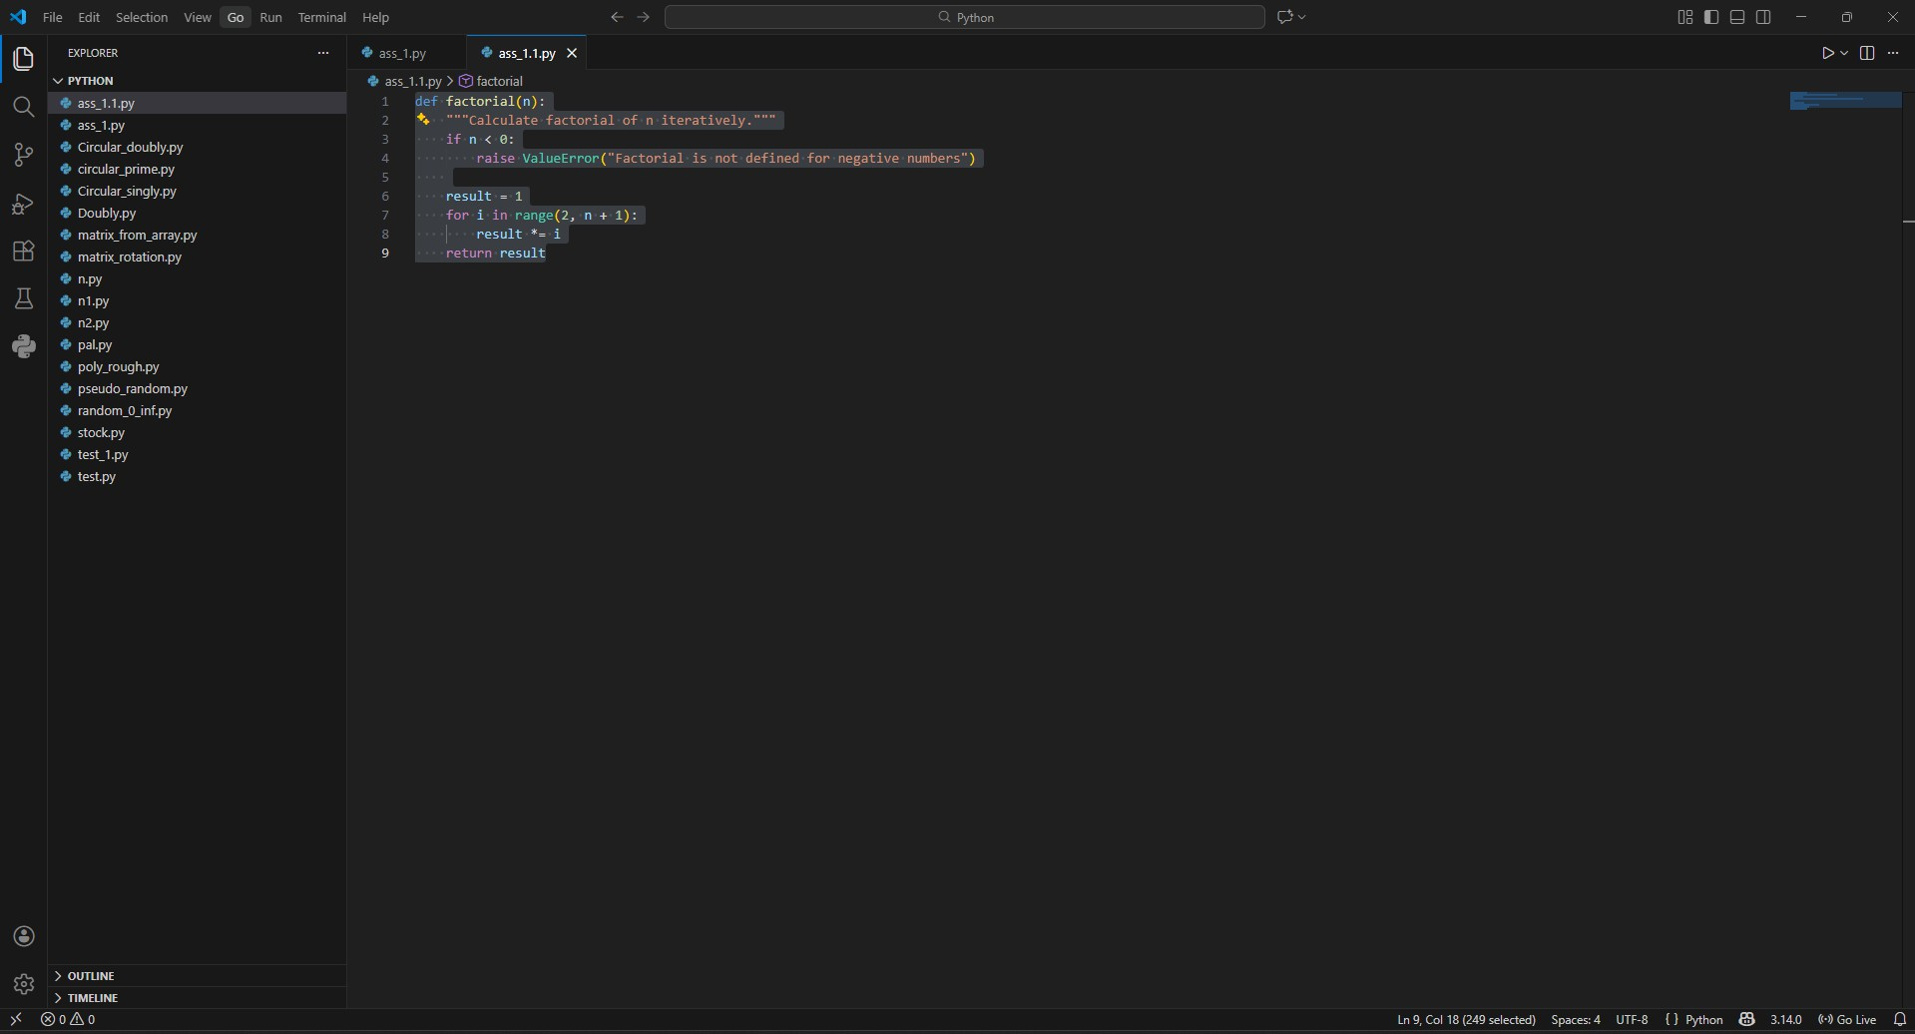
Code:
def factorial(n):
"""Calculate factorial of n iteratively.""" if n < 0:
raise ValueError("Factorial is not defined for negative numbers")

result = 1
for i in range(2, n + 1): result *= i
return result

An recursive version of the code:

Instruction Given:
Write a recursive function to calculate factorial in Python

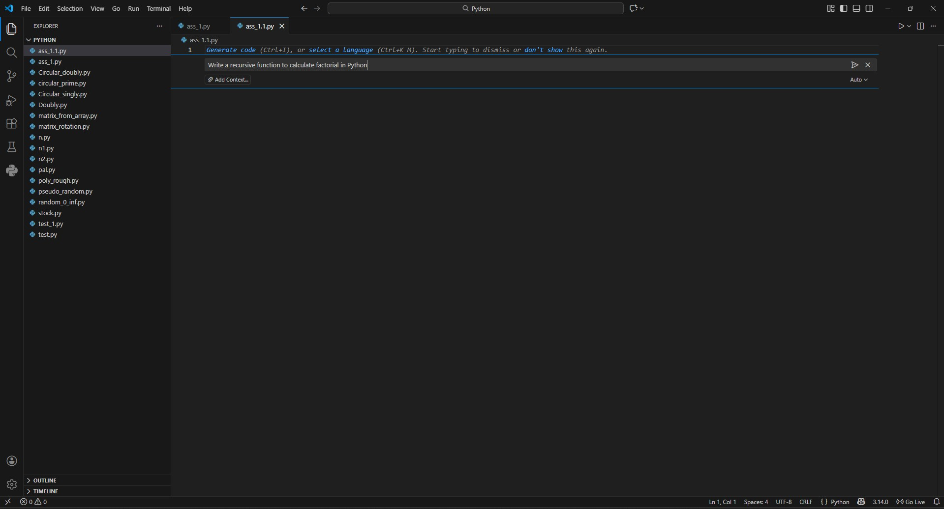
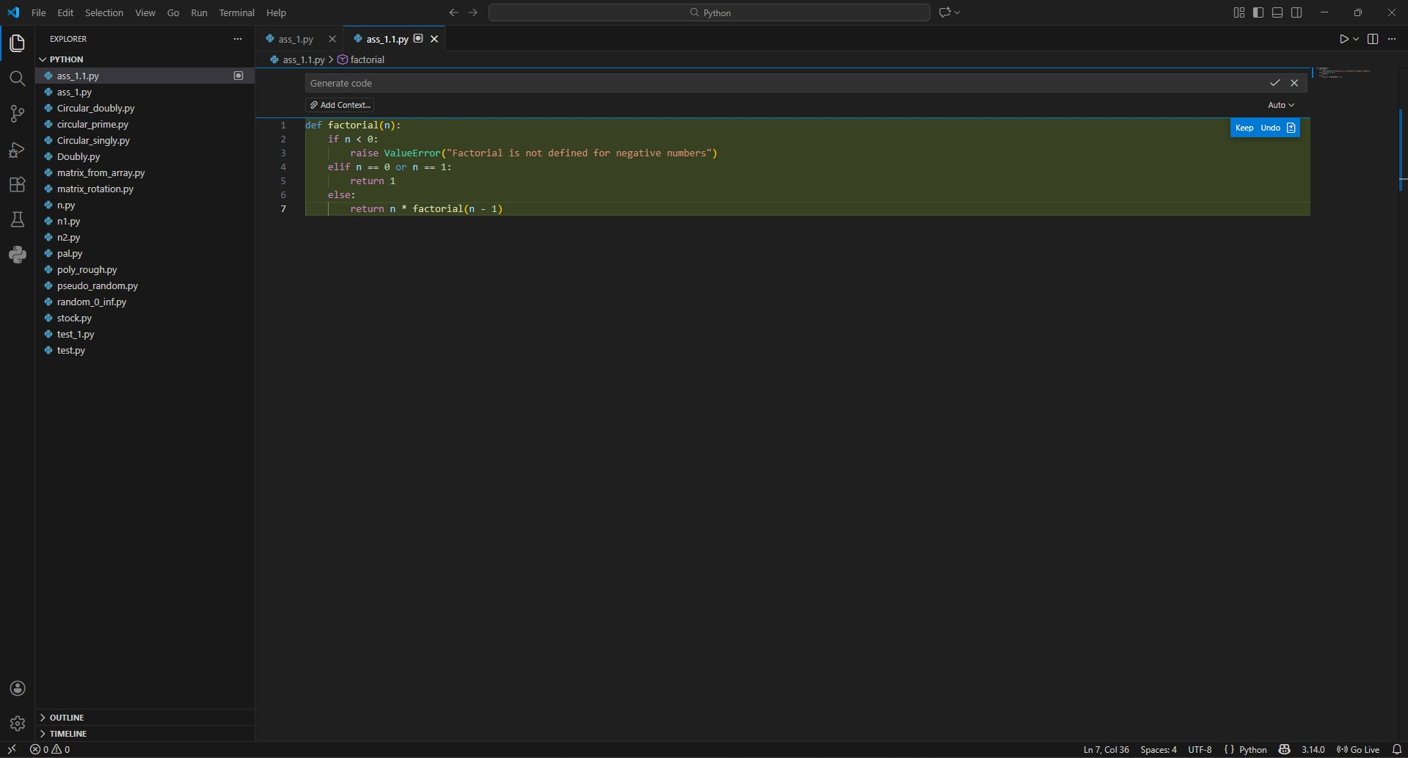

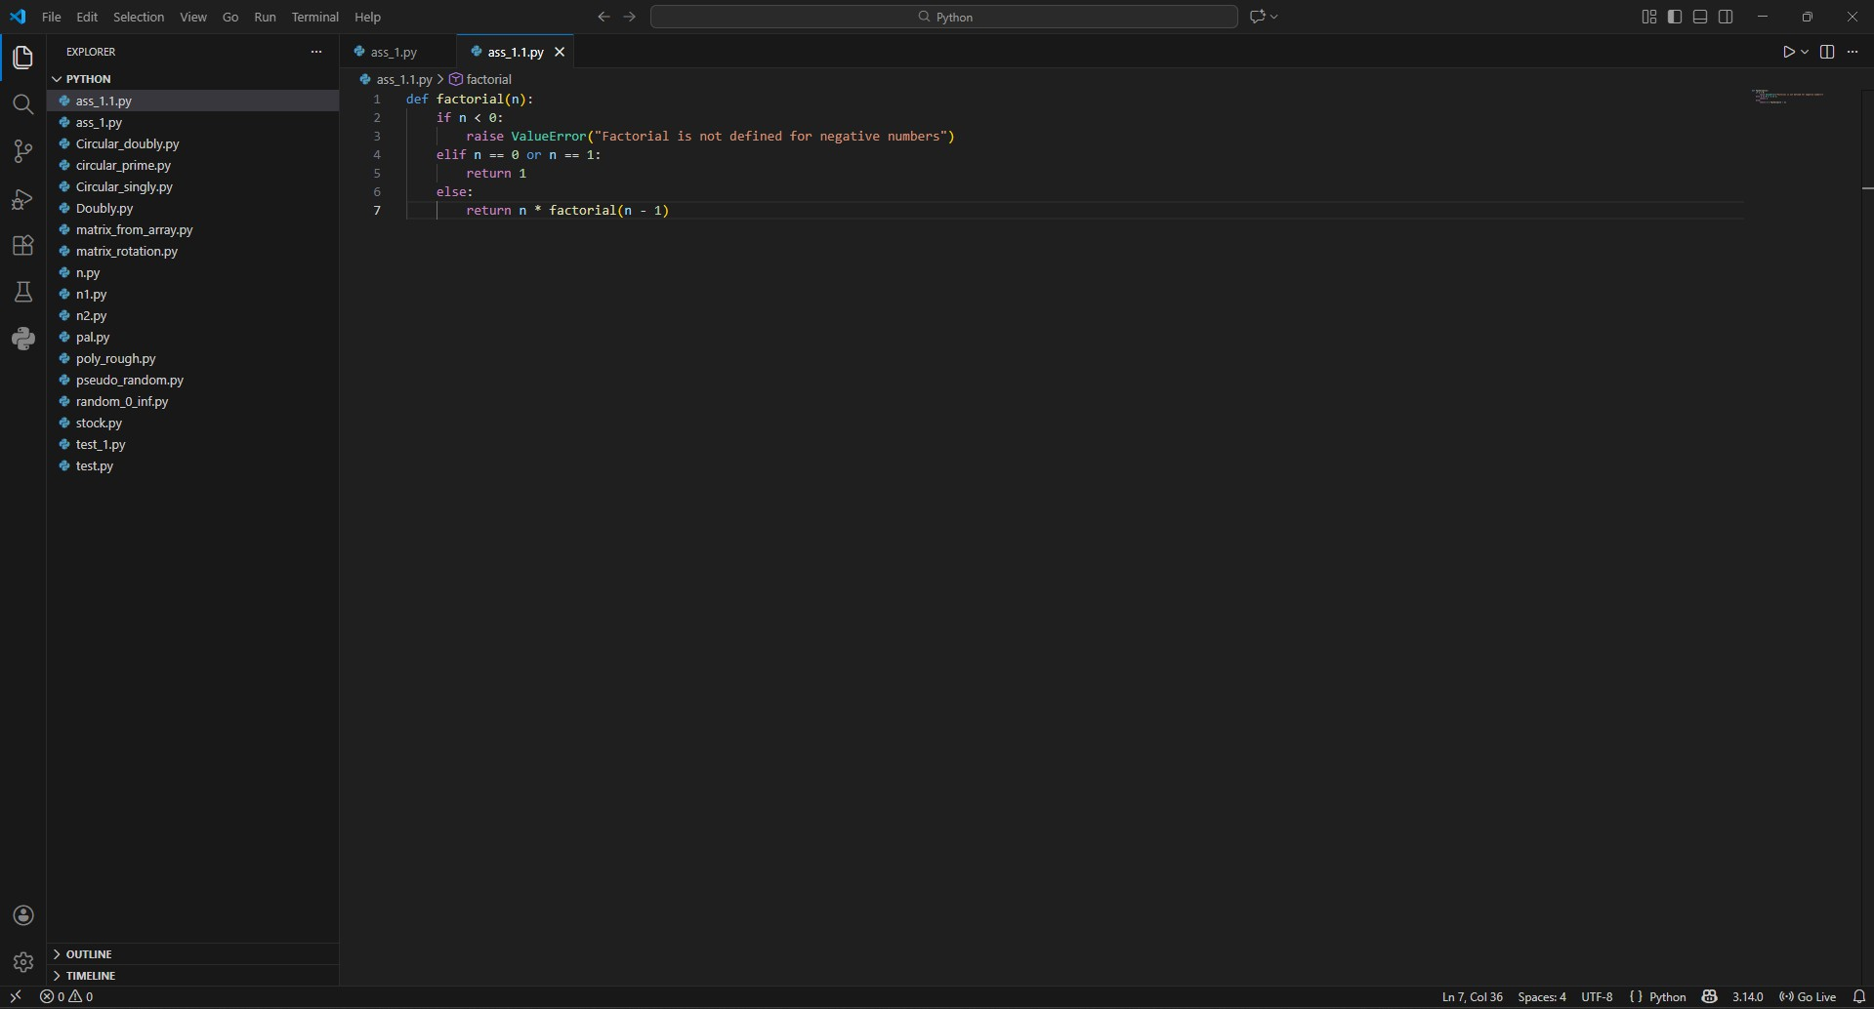
Code:
def factorial(n): if n < 0:
raise ValueError("Factorial is not defined for negative numbers") elif n == 0 or n == 1:
return 1 else:
return n * factorial(n - 1)
Comparison Iterative vs Recursive:
Aspect | Iterative | Recursive
Readability | Clear, linear flow | Elegant mathematical definition
Stack Usage | O(1) constant | O(n) linear
Performance | Faster, no function call overhead | Slower due to function calls
Memory | Minimal | Uses call stack
Error Case | Handles large n better | Recursion depth limit (∼1000)
When recursion is not recommended:
- For very large inputs due to Python's recursion depth limit (default ∼1000)
- When performance is critical due to function call overhead
- In production systems where stack overflow could crash the application
- When the problem doesn't naturally fit recursive patterns

Copilot Suggestions:
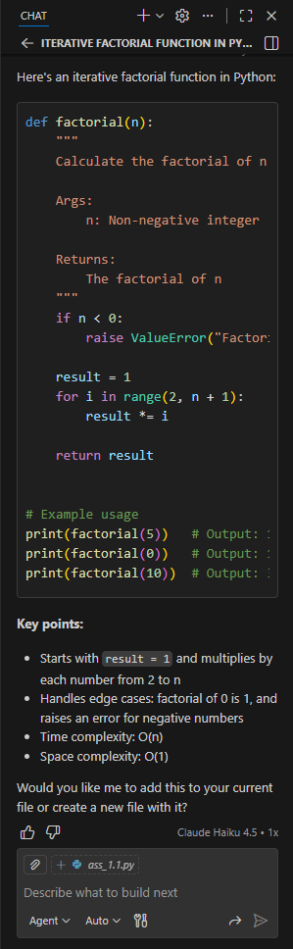
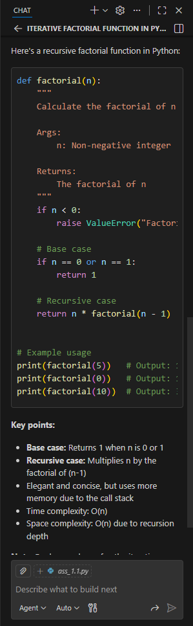

Input/Output:
Testing n = -5:
Iterative: ValueError - Factorial not defined for negatives Recursive: ValueError - Factorial not defined for negatives
→ Both handle errors correctly

Testing n=1000:
Iterative: Computes successfully
Recursive: RecursionError - Maximum depth exceeded
→ Recursive fails for large input.
Error for recursive factorial where as iterative gives direct answer:
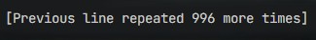

Therefore, it is mostly recommended to use iterative rather than recursive, due to its recursion limit.

